Case Study: 7
Title: To generate a registration form using html,css, js with showing the live errors for filling the credentials.
Software/Tools Required: VSC, HTML, CSS, JavaScript
Case Study program code:
index.html:
<!DOCTYPE html>
<html lang="en">
<head>
<meta charset="UTF-8">
<meta name="viewport" content="width=device-width, initial-scale=1.0">
<title>JavaScript Event Handling and Form Validation</title>

<link rel="stylesheet" href="style.css">
</head>

<body>

<div class="container">

<h1>Registration Form</h1>
<p class="subtitle">JavaScript Event Handling & Form Validation</p>

<form id="registrationForm">

<!-- First Name -->
<div class="form-group">
<label for="firstName">First Name</label>
<input type="text" id="firstName" placeholder="Enter first name">
<span class="error" id="firstNameError"></span>
</div>

<!-- Last Name -->
<div class="form-group">
<label for="lastName">Last Name</label>
<input type="text" id="lastName" placeholder="Enter last name">
<span class="error" id="lastNameError"></span>
</div>

<!-- Email -->
<div class="form-group">
<label for="email">Email</label>
<input type="email" id="email" placeholder="Enter email">
<span class="error" id="emailError"></span>
</div>

<!-- Birthday -->
<div class="form-group">
<label for="birthday">Birthday</label>
<input type="date" id="birthday">
<span class="error" id="birthdayError"></span>
</div>

<!-- Password -->
<div class="form-group">
<label for="password">Password</label>
<input type="password" id="password" placeholder="Enter password">
<span class="error" id="passwordError"></span>
</div>

<!-- Re-enter Password -->
<div class="form-group">
<label for="confirmPassword">Re-enter Password</label>
<input type="password" id="confirmPassword" placeholder="Re-enter password">
<span class="error" id="confirmPasswordError"></span>
</div>

<!-- Terms -->
<div class="terms">
<input type="checkbox" id="terms">
<label for="terms">
I agree to the Terms and Conditions
</label>
</div>

<span class="error" id="termsError"></span>

<!-- Submit -->
<button type="submit">Register</button>

<div id="successMessage" class="success"></div>

</form>

</div>

<script src="script.js"></script>

</body>
</html>

Script.js:
// Accessing form elements using JavaScript

const form = document.getElementById("registrationForm");

const firstName = document.getElementById("firstName");
const lastName = document.getElementById("lastName");
const email = document.getElementById("email");
const birthday = document.getElementById("birthday");
const password = document.getElementById("password");
const confirmPassword = document.getElementById("confirmPassword");
const terms = document.getElementById("terms");

// --------------------------------------------------
// FOCUS EVENT
// --------------------------------------------------

// When an input receives focus
firstName.addEventListener("focus", function () {
firstName.style.backgroundColor = "#f2f2f2";
});

lastName.addEventListener("focus", function () {
lastName.style.backgroundColor = "#f2f2f2";
});

email.addEventListener("focus", function () {
email.style.backgroundColor = "#f2f2f2";
});

password.addEventListener("focus", function () {
password.style.backgroundColor = "#f2f2f2";
});

// --------------------------------------------------
// CHANGE EVENT
// --------------------------------------------------

// Change event is triggered when the value is changed
// and the user moves away from the input.

firstName.addEventListener("change", function () {
validateFirstName();
});

lastName.addEventListener("change", function () {
validateLastName();
});

email.addEventListener("change", function () {
validateEmail();
});

birthday.addEventListener("change", function () {
validateBirthday();
});

password.addEventListener("change", function () {
validatePassword();
});

confirmPassword.addEventListener("change", function () {
validateConfirmPassword();
});

terms.addEventListener("change", function () {
validateTerms();
});

// --------------------------------------------------
// VALIDATION FUNCTIONS
// --------------------------------------------------

function validateFirstName() {

const value = firstName.value.trim();
const error = document.getElementById("firstNameError");

if (value === "") {
error.textContent = "First name is required.";
return false;
}

error.textContent = "";
return true;
}

function validateLastName() {

const value = lastName.value.trim();
const error = document.getElementById("lastNameError");

if (value === "") {
error.textContent = "Last name is required.";
return false;
}

error.textContent = "";
return true;
}

function validateEmail() {

const value = email.value.trim();
const error = document.getElementById("emailError");

// Email validation pattern
const emailPattern = /^[^\s@]+@[^\s@]+\.[^\s@]+$/;

if (value === "") {
error.textContent = "Email is required.";
return false;
}

if (!emailPattern.test(value)) {
error.textContent = "Enter a valid email address.";
return false;
}

error.textContent = "";
return true;
}

function validateBirthday() {

const value = birthday.value;
const error = document.getElementById("birthdayError");

if (value === "") {
error.textContent = "Birthday is required.";
return false;
}

error.textContent = "";
return true;
}

function validatePassword() {

const value = password.value;
const error = document.getElementById("passwordError");

if (value === "") {
error.textContent = "Password is required.";
return false;
}

if (value.length < 6) {
error.textContent = "Password must contain at least 6 characters.";
return false;
}

error.textContent = "";
return true;
}

function validateConfirmPassword() {

const value = confirmPassword.value;
const error = document.getElementById("confirmPasswordError");

if (value === "") {
error.textContent = "Please re-enter your password.";
return false;
}

if (value !== password.value) {
error.textContent = "Passwords do not match.";
return false;
}

error.textContent = "";
return true;
}

function validateTerms() {

const error = document.getElementById("termsError");

if (!terms.checked) {
error.textContent = "You must agree to the Terms and Conditions.";
return false;
}

error.textContent = "";
return true;
}

// --------------------------------------------------
// SUBMIT EVENT
// --------------------------------------------------

form.addEventListener("submit", function (event) {

// Prevent page from refreshing
event.preventDefault();

// Validate every input
const isFirstNameValid = validateFirstName();
const isLastNameValid = validateLastName();
const isEmailValid = validateEmail();
const isBirthdayValid = validateBirthday();
const isPasswordValid = validatePassword();
const isConfirmPasswordValid = validateConfirmPassword();
const isTermsValid = validateTerms();

const successMessage = document.getElementById("successMessage");

// Check if all validations are successful
if (
isFirstNameValid &&
isLastNameValid &&
isEmailValid &&
isBirthdayValid &&
isPasswordValid &&
isConfirmPasswordValid &&
isTermsValid
) {

successMessage.textContent =
"Registration successful!";

// Display entered data in console
console.log("First Name:", firstName.value);
console.log("Last Name:", lastName.value);
console.log("Email:", email.value);
console.log("Birthday:", birthday.value);
console.log("Password:", password.value);

// Reset form after successful submission
form.reset();

} else {

successMessage.textContent = "";
}
});

Style.css:
* {
box-sizing: border-box;
margin: 0;
padding: 0;
}

body {
font-family: Arial, sans-serif;
background-color: #f4f6f8;
min-height: 100vh;
display: flex;
justify-content: center;
align-items: center;
padding: 30px;
}

.container {
background-color: white;
width: 100%;
max-width: 550px;
padding: 30px;
border-radius: 12px;
box-shadow: 0 4px 15px rgba(0, 0, 0, 0.1);
}

h1 {
text-align: center;
margin-bottom: 8px;
}

.subtitle {
text-align: center;
color: #666;
margin-bottom: 25px;
}

.form-group {
margin-bottom: 18px;
}

label {
display: block;
margin-bottom: 7px;
font-weight: bold;
}

input[type="text"],
input[type="email"],
input[type="date"],
input[type="password"] {
width: 100%;
padding: 12px;
border: 1px solid #ccc;
border-radius: 6px;
font-size: 15px;
}

input:focus {
outline: none;
border: 2px solid #555;
}

.terms {
display: flex;
align-items: center;
gap: 8px;
margin-top: 15px;
}

.terms label {
margin: 0;
font-weight: normal;
}

.error {
display: block;
color: #d00000;
font-size: 13px;
margin-top: 5px;
min-height: 17px;
}

.success {
color: green;
text-align: center;
font-weight: bold;
margin-top: 20px;
}

button {
width: 100%;
padding: 13px;
margin-top: 20px;
border: none;
border-radius: 6px;
background-color: #333;
color: white;
font-size: 16px;
cursor: pointer;
}

button:hover {
background-color: #555;
}

Output:
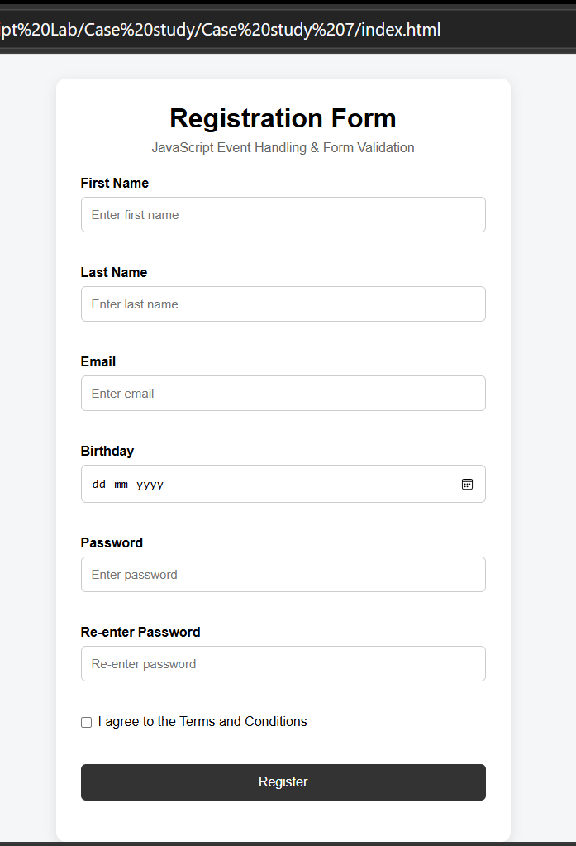

RESULT
The experiment was successfully performed and the registration form using html, css and js was implemented showing live errors.

